

**SOFTWARE ENGINEERING LAB FILE**

**SUBMITTED BY: AYUSH MENDIRATTA**

**CSE-4B**

**2k21CSUN01057**

**SUBMITTED TO:MR.AGHA IMRAN HUSAIN**

**LAB-1**

**REQUIREMENTS FOR SOFTWARE-BANK MANAGEMENT SYSTEM**

* Customer:
  1. Sign in with login and password.
  2. Update personal details.
  3. Change password.
  4. View balance.
  5. View personal history of transactions.
  6. Transfer money.
  7. Withdraw.
  8. Submit Cash.
* Teller:
  1. Sign in with login and password.
  2. Change password.
  3. Register new bank customers.
  4. View customer information.
  5. Manage customer accounts.
* Admin:
  1. Sign in with login and password.
  2. View manager and customer details.
  3. Add or update bank branch details.
  4. Add or update manager details.

**LAB-2**

1. A college wishes to develop a software system for Result management System activities. Design a problem statement for it.
2. **Problem Statement**

Result Management of X University exists which consist following problems-

* Computation of Result is a time taking procedure.
* Student do not get to know the break-up of all marks scored during semester
* The list of Supplementary or PSC students is to be mentioned
* Students are not able to view result after every internal examination.

1. Identify the requirements of the project from the problem statement.
2. **Requirements**

* Result must be declared early
* Students must be able to see all the marks (internal as well as external)
* Only supplementary and PSC students must get information regarding their results.

1. A company wishes to develop a software system for payroll management activities. Design the problem statement for the company.
2. **Problem Statement**

A Payroll management exists for the XY company which consist the following Problems-

* System storing information of employee capacity is less.
* Employee are not able to update their personal information (name ,address ,passwords)
* System not able to initiate the payment process based on selected list of employees.

1. Identify the requirements of the project from the problem statement.
2. **Requirements**

* Overall system must store the information of approximately 2000 employees
* Employee should be given right to update its personal information
* System should be able to initiate the payment process based on selected list of employees

1. A factory wishes to develop a software system for inventory management activities. Design the problem statement for the factory.
2. **Problem Statement**

AN Inventory management system exists for the ZC Company and has following problems

* Lack of inventory visibility
* Not able to manage the Inventory Waste and defects
* Lack of Centralized Inventory Hub

1. Identify the requirements of the project from the problem statement.
2. **Requirements-**

* Real Time Inventory Management Should be built to get accurate data
* Central Inventory System to track the inventory
* Robust Inventory Management that enables to manage and control the waste production.

**LAB -3**

Q1. Draw use case diagram of library management system

**STUDENT**

**LIBRARIAN**

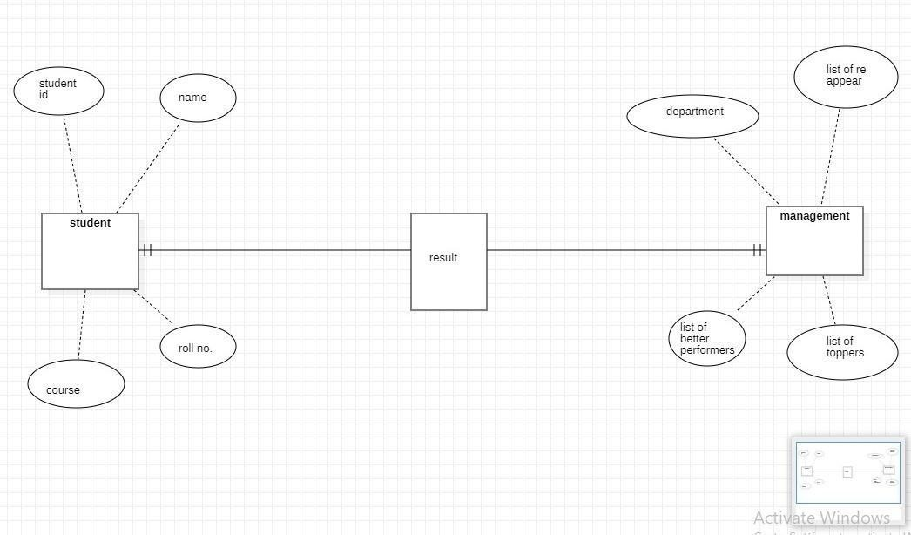Q2. Draw the E-R diagram for a Result Management System**.**

**LAB-4**

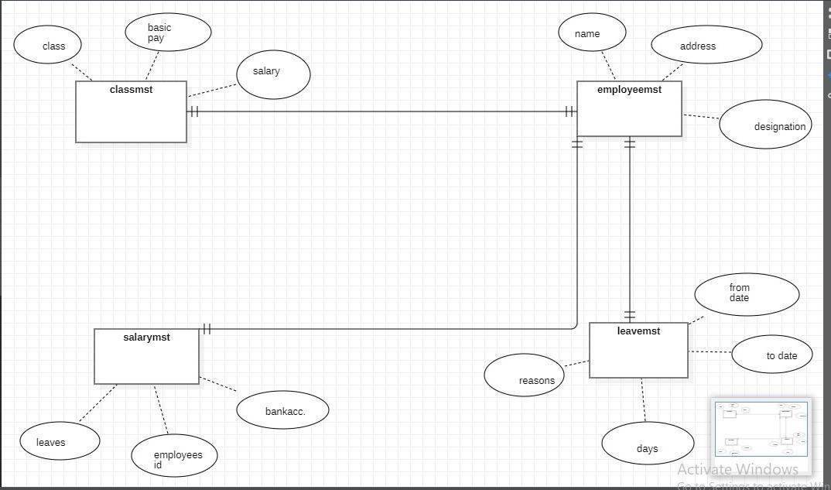Q1.Draw ER diagram for payroll system

Q2.Draw ER diagram for an inventory management system

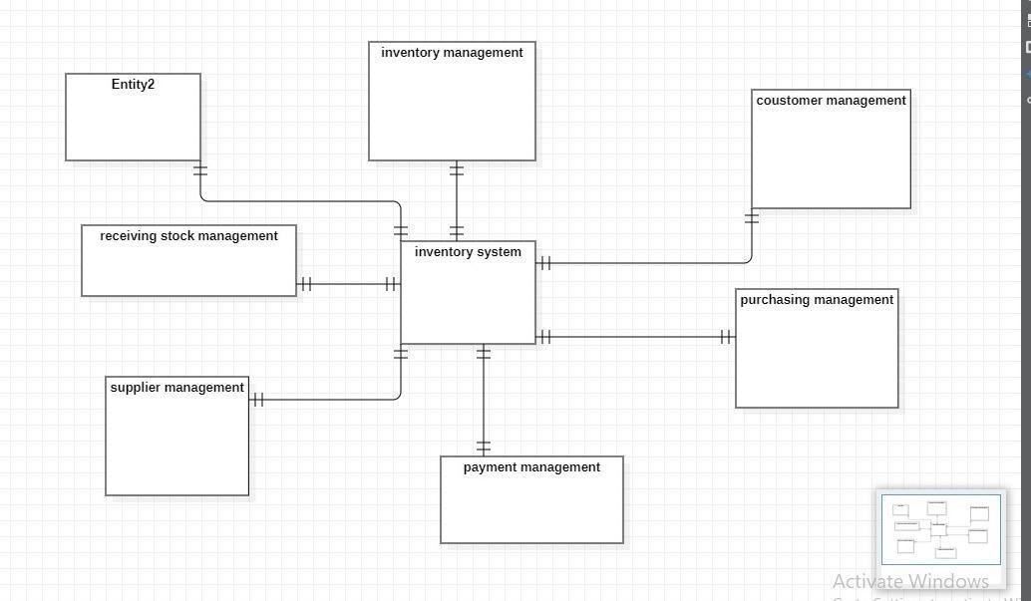

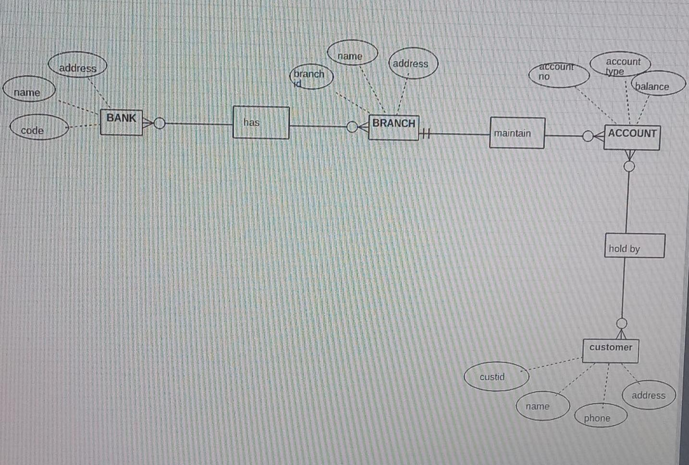Q3.Draw ER diagram for bank management system

**LAB-5**

* Book returning system

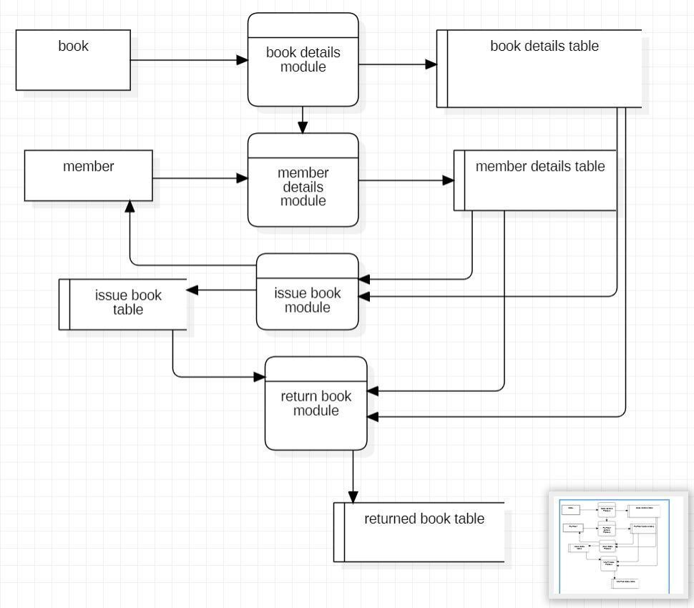

* Library management system

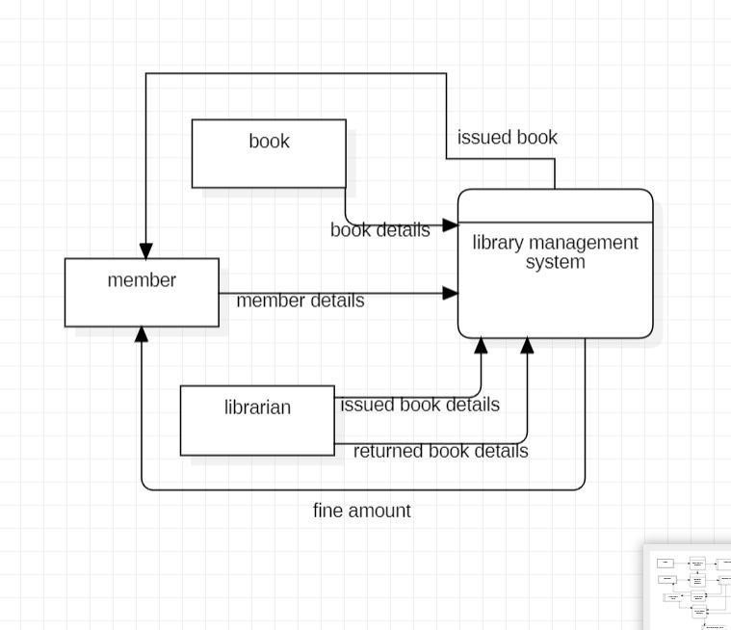

* Payroll management system

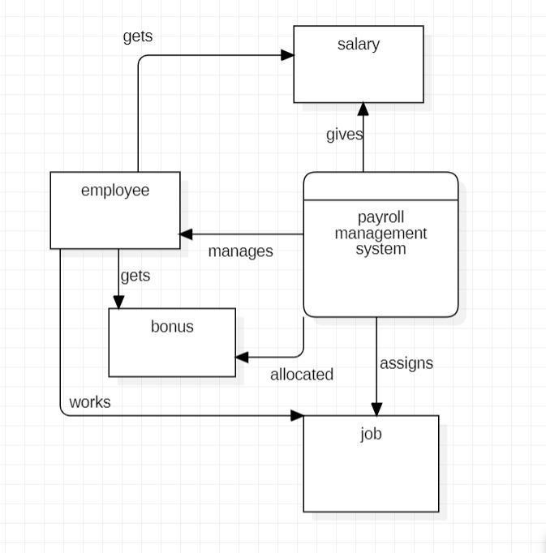

* Job management system

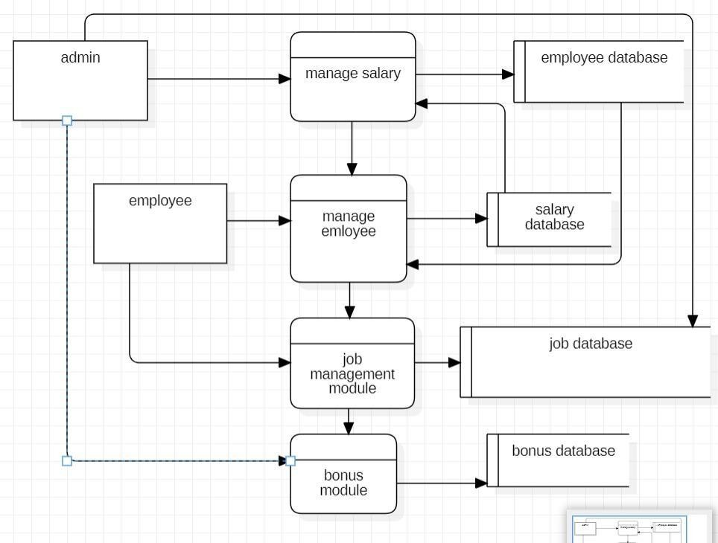

**LAB-6**

* 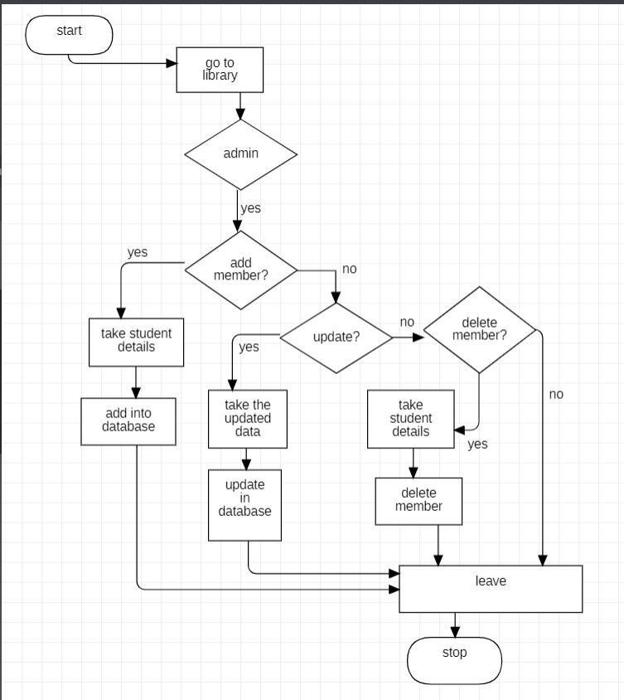Draw login activity diagram for library management system

**LAB-7**

* Draw activity diagram for library management system

a)

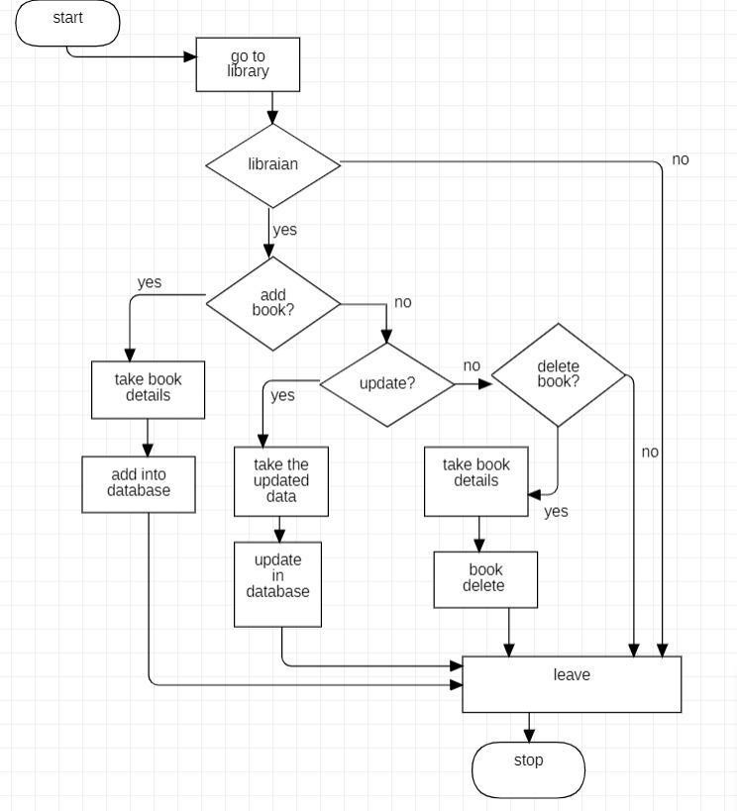

b)

